LAB TASK 06

TASK NO 1:

#include<iostream>

using namespace std;

class Employee{

string name;

float salary;

public:

Employee(string n, float s)

{

name=n;

salary=s;

}

void displayDetail()

{

cout<<"------------------------------------"<<endl;

cout<<"NAME: "<<name<<endl;

cout<<"SALARY: "<<salary<<endl;

}

string getter_name()

{

return name;

}

float getter_salary()

{

return salary;

}

};

class Manager:public Employee{

float bonus;

public:

Manager(string n, float s, float b):Employee(n,s),

bonus(b){}

void displayDetail()

{

cout<<"------------------------------------"<<endl;

cout<<"NAME: "<<getter_name()<<endl;

cout<<"SALARY: "<<getter_salary()<<endl;

cout<<"BONUS: %"<<bonus<<endl;

}

};

int main()

{

string name;

float salary,bonus;

cout<<"ENTER THE NAME OF THE EMPLOYEE: "<<endl;

cin>>name;

cout<<"ENTER THE SALARY OF THE EMPLOYEE: "<<endl;

cin>>salary;

cout<<"ENTER THE BONUS OF THE EMPLOYEE: "<<endl;

cin>>bonus;

Manager M1(name,salary,bonus);

M1.displayDetail();

}

OUTPUT:

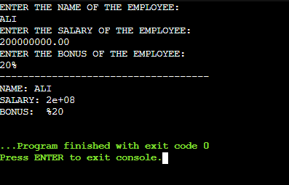

TASK NO 2:

#include<iostream>

using namespace std;

class Vehicle{

string brand;

int speed;

public:

Vehicle(string b, int s)

{

brand=b;

speed=s;

}

void displaydetails()

{

cout<<"----------------------------------------"<<endl;

cout<<"BRAND: "<<brand<<endl;

cout<<"SPEED: "<<speed<<endl;

}

string getter_brand()

{

return brand;

}

int getter_speed()

{

return speed;

}

};

class Car:public Vehicle{

int seats;

public:

Car(string b, int s, int se):Vehicle(b,s),

seats(se){}

void displaydetails()

{

cout<<"=========================================="<<endl;

cout<<"BRAND: "<<getter_brand()<<endl;

cout<<"SPEED: "<<getter_speed()<<endl;

cout<<"SEATS: "<<seats<<endl;

}

int getter_seats()

{

return seats;

}

};

class ElectricCar: public Car{

int batteryLife;

public:

ElectricCar(string b,int s,int se, int l):Car(b,s,se),

batteryLife(l){}

void displaydetails()

{

cout<<"======================================="<<endl;

cout<<"BRAND: "<<getter_brand()<<endl;

cout<<"SPEED: "<<getter_speed()<<endl;

cout<<"SEATS: "<<getter_seats()<<endl;

cout<<"BATTERY LIFE: "<<batteryLife<<endl;

}

};

int main()

{

string brand;

int speed;

int seats;

int batteryLife;

cout<<"ENTER THE BRAND: "<<endl;

cin>>brand;

cout<<"ENTER THE SPEED: "<<endl;

cin>>speed;

cout<<"ENTER THE SEATS: "<<endl;

cin>>seats;

cout<<"ENETR THE BATTERY LIFE: "<<endl;

cin>>batteryLife;

ElectricCar E1(brand,speed,seats,batteryLife);

E1.displaydetails();

}

OUTPUT:

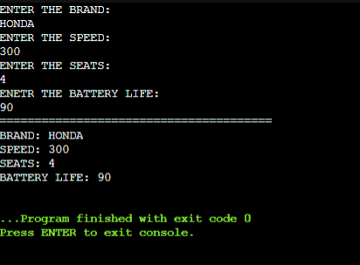

TASK NO 3:

#include<iostream>

using namespace std;

class Person{

string name;

int age;

public:

Person(string n, int a)

{

name=n;

age=a;

}

void displayDetails()

{

cout<<"-----------------------------"<<endl;

cout<<"NAME: "<<name<<endl;

cout<<"AGE: "<<age<<endl;

}

string getter_name()

{

return name;

}

int getter_age()

{

return age;

}

};

class Teacher:public Person{

string subject;

public:

Teacher(string n, int a, string s):Person(n,a),

subject(s){}

void displayDetails()

{

cout<<"-----------------------------"<<endl;

cout<<"NAME: "<<getter_name()<<endl;

cout<<"AGE: "<<getter_age()<<endl;

cout<<"SUBJECT: "<<subject<<endl;

}

string getter_subject()

{

return subject;

}

};

class Researcher:public Person{

string researchArea;

public:

Researcher(string n,int a,string r):Person(n,a),

researchArea(r){}

void displayDetails()

{

cout<<"-----------------------------"<<endl;

Person::displayDetails();

cout<<"RESEARCH AREA: "<<researchArea<<endl;

}

string getter_researchArea()

{

return researchArea;

}

};

class Professor:public Researcher,public Teacher{

int publications;

public:

Professor(string n,int a,string s,string r,int p):Researcher(n,a,r),

Teacher(n,a,s),

publications(p){}

void displayDetails()

{

cout<<"-----------------------------"<<endl;

Teacher::displayDetails();

cout<<"RESEARCH AREA: "<<getter_researchArea()<<endl;

cout<<"PUBLICATIONS: "<<publications<<endl;

}

};

int main()

{

string name,subject,research_area;

int age,publications;

cout<<"ENTER THE DETAILS OF THE PROFESSOR:"<<endl;

cout<<"1-NAME: 2-AGE: 3-SUBJECT: 4-RESEARCH AREA: 5-PUBLICATIONS:"<<endl;

cin>>name>>age>>subject>>research_area>>publications;

Professor P1(name,age,subject,research_area,publications);

P1.displayDetails();

}

OUTPUT:

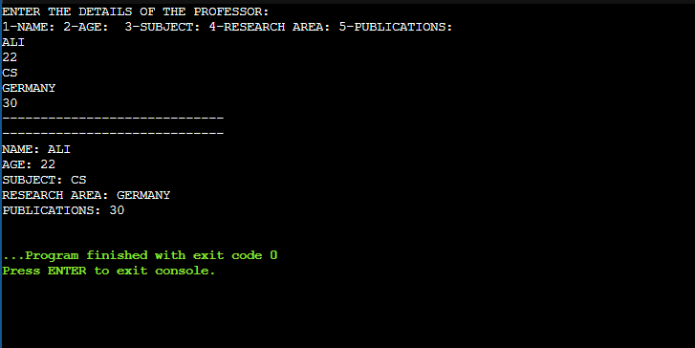

TASK NO 4:

#include<iostream>

using namespace std;

class Account {

int accountNumber;

float balance;

public:

Account(int a, float b) {

accountNumber = a;

balance = b;

}

void displayDetails() {

cout << "=========================================" << endl;

cout << "ACCOUNT NUMBER: " << getter_accountNumber() << endl;

cout << "BALANCE: " << getter_balance() << endl;

}

int getter_accountNumber() {

return accountNumber;

}

float getter_balance() {

return balance;

}

};

class SavingAccount : public Account {

float interestRate;

public:

SavingAccount(int a, float b, float i) : Account(a, b), interestRate(i) {}

void displayDetails() {

Account::displayDetails();

cout << "INTEREST RATE: " << interestRate << "%" << endl;

}

float getter_interestRate() {

return interestRate;

}

};

class CheckingAccount : public Account {

float overDraftLimit;

public:

CheckingAccount(int a, float b, float o) : Account(a, b), overDraftLimit(o) {}

void displayDetails() {

Account::displayDetails();

cout << "OVER DRAFT LIMIT: $" << overDraftLimit << endl;

}

};

int main() {

int accountNumber;

float balance, interestRate, overDraftLimit;

cout << "ENTER ACCOUNT NUMBER: ";

cin >> accountNumber;

cout << "ENTER BALANCE: ";

cin >> balance;

cout << "ENTER INTEREST RATE (for savings account): ";

cin >> interestRate;

cout << "ENTER OVERDRAFT LIMIT (for checking account): ";

cin >> overDraftLimit;

cout << "\n---- SAVING ACCOUNT DETAILS ----" << endl;

SavingAccount S1(accountNumber, balance, interestRate);

S1.displayDetails();

cout << "\n---- CHECKING ACCOUNT DETAILS ----" << endl;

CheckingAccount C1(accountNumber, balance, overDraftLimit);

C1.displayDetails();

return 0;

}

OUTPUT:

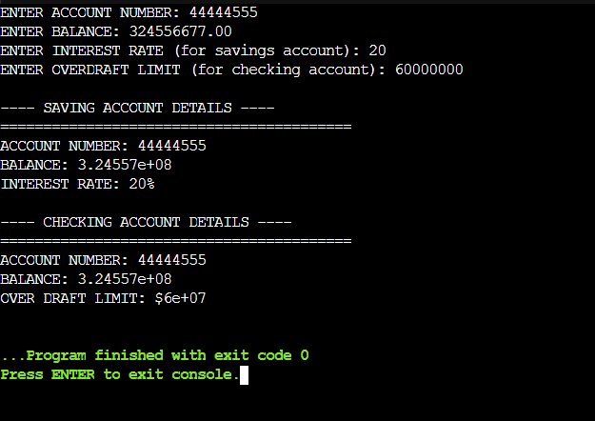

TASK NO 5:

#include <iostream>

using namespace std;

class Device {

protected:

int deviceID;

bool status;

public:

Device(int id, bool st) {

deviceID = id;

status = st;

}

void displayDetails() {

cout << "=========================================" << endl;

cout << "DEVICE ID: " << deviceID << endl;

cout << "STATUS: " << (status ? "ON" : "OFF") << endl;

}

};

class SmartPhone : virtual public Device {

protected:

float screenSize;

public:

SmartPhone(int id, bool st, float size) : Device(id, st), screenSize(size) {}

void displayDetails() {

Device::displayDetails();

cout << "SCREEN SIZE: " << screenSize << " inches" << endl;

}

};

class SmartWatch : virtual public Device {

protected:

bool heartRateMonitor;

public:

SmartWatch(int id, bool st, bool hrm) : Device(id, st), heartRateMonitor(hrm) {}

void displayDetails() {

Device::displayDetails();

cout << "HEART RATE MONITOR: " << (heartRateMonitor ? "Yes" : "No") << endl;

}

};

class SmartWearable : public SmartPhone, public SmartWatch {

int stepCounter;

public:

SmartWearable(int id, bool st, float size, bool hrm, int steps)

: Device(id, st), SmartPhone(id, st, size), SmartWatch(id, st, hrm), stepCounter(steps) {}

void displayDetails() {

SmartPhone::displayDetails();

cout << "HEART RATE MONITOR: " << (heartRateMonitor ? "Yes" : "No") << endl;

cout << "STEP COUNTER: " << stepCounter << " steps" << endl;

}

};

int main() {

int deviceID, stepCounter;

bool status, heartRateMonitor;

float screenSize;

cout << "ENTER DEVICE ID: ";

cin >> deviceID;

cout << "ENTER STATUS (1 for ON, 0 for OFF): ";

cin >> status;

cout << "ENTER SCREEN SIZE (in inches): ";

cin >> screenSize;

cout << "HEART RATE MONITOR AVAILABLE? (1 for YES, 0 for NO): ";

cin >> heartRateMonitor;

cout << "ENTER STEP COUNTER VALUE: ";

cin >> stepCounter;

SmartWearable SW(deviceID, status, screenSize, heartRateMonitor, stepCounter);

SW.displayDetails();

return 0;

}

OUTPUT:

